Cryptography Laboratory Experiments (Python)

Experiment No: 1
Experiment Name: Caesar Cipher
Aim: To implement the Caesar Cipher technique for encryption and decryption using Python.
Algorithm:
- Read the plaintext.
- Read the key value.
- Encrypt each alphabet by shifting with the key.
- Decrypt by reversing the shift.
- Display the encrypted and decrypted text.
Code:
# Caesar Cipher
plain_text = input("Enter the plain text: ")
key = int(input("Enter the key value: "))
cipher_text = ""
for ch in plain_text:
if ch.isupper():
cipher_text += chr((ord(ch)-65+key)%26+65)
elif ch.islower():
cipher_text += chr((ord(ch)-97+key)%26+97)
else:
cipher_text += ch
print("Encrypted Text:", cipher_text)
decrypted_text=""
for ch in cipher_text:
if ch.isupper():
decrypted_text += chr((ord(ch)-65-key)%26+65)
elif ch.islower():
decrypted_text += chr((ord(ch)-97-key)%26+97)
else:
decrypted_text += ch
print("Decrypted Text:", decrypted_text)
Sample Input:
Hello world
4
Sample Output/Result:

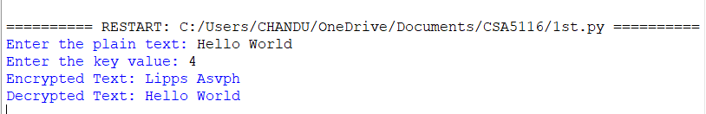

Experiment No: 2
Experiment Name: Playfair Cipher
Aim: To implement the Playfair Cipher substitution technique using Python.
Algorithm:
- Read the keyword.
- Generate the 5×5 key matrix.
- Prepare plaintext as digraphs.
- Apply Playfair rules.
- Display the ciphertext.
Code:
def key_matrix(key):
key = key.upper().replace("J", "I")
s = ""
for c in key + "ABCDEFGHIKLMNOPQRSTUVWXYZ":
if c.isalpha() and c not in s:
s += c
return [list(s[i:i+5]) for i in range(0, 25, 5)]

def pos(mat, ch):
if ch == "J":
ch = "I"
for i in range(5):
for j in range(5):
if mat[i][j] == ch:
return i, j

key = input("Enter Key: ")
text = input("Enter Plaintext: ").upper().replace("J", "I").replace(" ", "")

# Prepare text
prepared = ""
i = 0
while i < len(text):
a = text[i]
if i + 1 < len(text):
b = text[i + 1]
if a == b:
prepared += a + "X"
i += 1
else:
prepared += a + b
i += 2
else:
prepared += a + "X"
i += 1

mat = key_matrix(key)

print("\nKey Matrix:")
for row in mat:
print(*row)

print("\nPrepared Text:", prepared)

cipher = ""
for i in range(0, len(prepared), 2):
r1, c1 = pos(mat, prepared[i])
r2, c2 = pos(mat, prepared[i + 1])

if r1 == r2:
cipher += mat[r1][(c1 + 1) % 5] + mat[r2][(c2 + 1) % 5]
elif c1 == c2:
cipher += mat[(r1 + 1) % 5][c1] + mat[(r2 + 1) % 5][c2]
else:
cipher += mat[r1][c2] + mat[r2][c1]

print("Cipher Text:", cipher)
Sample Input:
Key: Network
Plain Text: CRYPTO
Sample Output/Result:
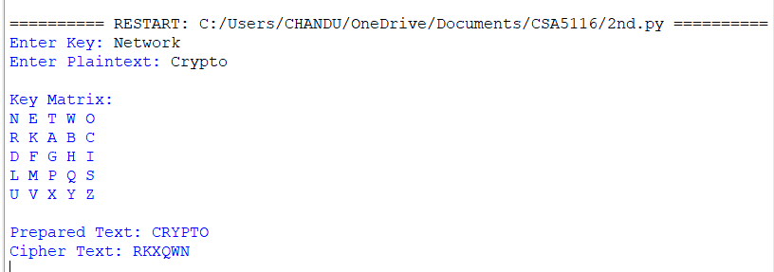

Experiment No: 3
Experiment Name: Hill Cipher
Aim: To implement the Hill Cipher substitution technique using Python.
Algorithm:
- Read a 3-letter plaintext.
- Convert letters to numbers.
- Multiply by the 3×3 key matrix.
- Take modulo 26.
- Decrypt using the inverse key matrix.
Code:
n = int(input("Enter matrix size: "))

print("Enter Key Matrix:")
key = [list(map(int, input().split())) for _ in range(n)]

text = input("Enter Plaintext: ").upper()

# Pad with X if needed
while len(text) % n != 0:
text += "X"

print("Prepared Text:", text)

cipher = ""

for k in range(0, len(text), n):
block = [ord(ch) - 65 for ch in text[k:k+n]]

for i in range(n):
s = 0
for j in range(n):
s += key[i][j] * block[j]
cipher += chr((s % 26) + 65)

print("Cipher Text:", cipher)
Sample Input:
Enter matrix size: 2
Enter Key Matrix:
3 3
2 5
Enter Plaintext: HI
Sample Output/Result:
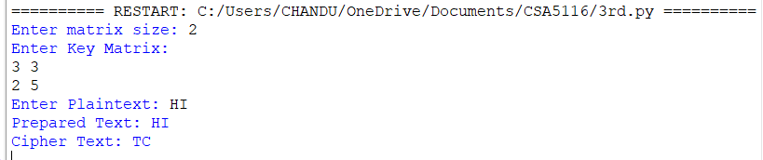

Experiment No: 4
Experiment Name: Vigenere Cipher
Aim: To implement the Vigenère Cipher using Python.
Algorithm:
- Read plaintext and keyword.
- Repeat the keyword.
- Encrypt using modular addition.
- Decrypt using modular subtraction.
- Display the results.
Code:
text = input("Enter Plaintext: ").upper()
key = input("Enter Key: ").upper()

# Repeat key
k = (key * (len(text)//len(key) + 1))[:len(text)]
print("Repeated Key:", k)

# Encryption
cipher = ""
for i in range(len(text)):
cipher += chr((ord(text[i]) + ord(k[i]) - 130) % 26 + 65)

print("Cipher Text:", cipher)

# Decryption
plain = ""
for i in range(len(cipher)):
plain += chr((ord(cipher[i]) - ord(k[i])) % 26 + 65)

print("Decrypted Text:", plain)
Sample Input:
Hello
key
Sample Output/Result:

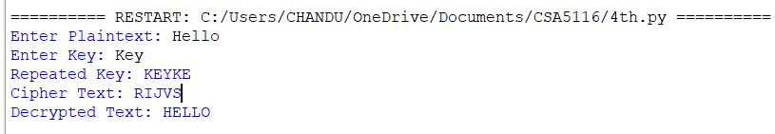

Experiment No: 5
Experiment Name: Rail Fence Cipher
Aim: To implement the Rail Fence Cipher using Python.
Algorithm:
- Read the plaintext.
- Form ciphertext from even and odd indexed characters.
- Split ciphertext.
- Merge alternately.
- Display decrypted text.
Code:
text = input("Enter Plaintext: ")

# Encryption
even = text[::2]
odd = text[1::2]
cipher = even + odd

print("Cipher Text:", cipher)

# Decryption
mid = (len(cipher) + 1) // 2
even = cipher[:mid]
odd = cipher[mid:]

plain = ""
for i in range(len(odd)):
plain += even[i] + odd[i]
if len(even) > len(odd):
plain += even[-1]

print("Decrypted Text:", plain)
Sample Input:
Helloworld
Sample Output/Result:

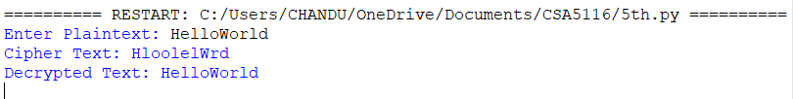

Experiment No: 6
Experiment Name: DES
Aim: To implement the Data Encryption Standard (DES) algorithm using Python.
Algorithm:
- Read the plaintext.
- Read an 8-byte key.
- Encrypt using DES.
- Decrypt using the same key.
- Display the results.
Code:
from Crypto.Cipher import DES
from Crypto.Util.Padding import pad, unpad
key=input("Enter 8-character key: ").encode()
plaintext=input("Enter the plain text: ")
cipher=DES.new(key, DES.MODE_ECB)
encrypted=cipher.encrypt(pad(plaintext.encode(), DES.block_size))
print(encrypted.hex())
print(unpad(cipher.decrypt(encrypted),DES.block_size).decode())
Sample Input:
Bujjihii
This is Cryptography
Sample Output/Result:
